# Installation And Maintenance Of Hardware And Its Components Section 1: Multiple Choice

1. Which of the following precautions should be taken before working on computer hardware? Ans. c) Work on carpeted surfaces to prevent slipping.
2. What is the purpose of thermal paste during CPU installation? Ans. a) To insulate the CPU from heat.
3. Which tool is used to measure the output voltage of a power supply unit (PSU)? Ans. a) Multimeter
4. Which component is responsible for storing BIOS settings, such as date and time, even when the computer is powered off?

Ans. a) CMOS battery

# Section 2: True or False

1. When installing a new hard drive, it is essential to format it before use. Ans: False
2. A POST (Power-On Self-Test) error indicates a problem with the CPU. Ans: False
3. It is safe to remove a USB flash drive from a computer without ejecting it first. Ans: False

# Section-3 Short answer

1. Describe the steps involved in installing a new graphics card in a desktop computer.

Ans:

# Open the Computer Case:

Depending on your case, you might need to unscrew or unclip the side panel.

1. **Identify the Slot:** Look for the PCI Express (PCIe) slot on your motherboard. It’s usually the longest slot and is often located near the CPU. Most modern graphics cards use the PCIe x16 slot.

# Remove the Old Graphics Card

If there’s an existing graphics card, unscrew the bracket holding it to the case.

1. **Check Compatibility:** Ensure the new card fits the PCIe slot and your case has enough space.

# Install the New Graphics Card

**Align the Card:** Line up the graphics card’s connector with the PCIe slot.

# Install Drivers and Software

Download and install the latest drivers for your new graphics card from the manufacturer’s website (e.g., NVIDIA or AMD).

1. What is RAID, and what are some common RAID configurations?

Ans:

RAID (Redundant Array of Independent Disks) is a data storage virtualization technology that combines multiple physical disk drives into one or more logical volumes. It provides fault tolerance, increased performance, and data redundancy.

# Types:

.1. RAID-0 (Stripping)

1. RAID-1 (Mirroring)
2. RAID-2
3. RAID-3
4. RAID-4
5. RAID-5
6. RAID-6

# Section 4. Practical Application

1. Demonstrate how to replace a CPU fan in a desktop computer.

Ans:

* + Identify the cpu fan. ➢Turn off and unplug the computer ➢Open the case and locate the fan

➢Remove the fan and clean the processor. ➢Install the new fan and apply thermal paste. ➢

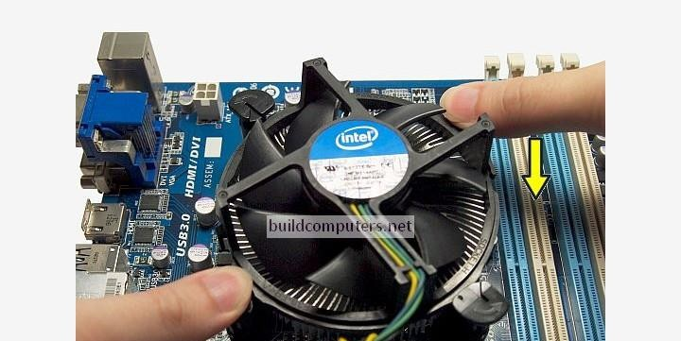Close the case and test the fan

# Section 5. Essay

1. Discuss the importance of regular maintenance for computer hardware and provide examples of maintenance tasks.

Ans:

Regular maintenance of computer hardware is essential not only for maximizing the longevity and efficiency of systems but also for preventing potential issues that could disrupt productivity. This essay explores the importance of regular hardware maintenance and provides examples of key maintenance tasks that help safeguard computer systems.

Regular maintenance also plays a critical role in preventing system failures. Many hardware issues develop gradually, and early intervention can prevent them from escalating into more serious problems. For example, failing hard drives may exhibit early warning signs such as unusual noises or slower read/write speeds.

# Example of maintenance tasks

Cleaning Internal Components: Checking and Updating Software Running Diagnostic Tools Performing Backup and Recovery